Name :

Class :

Roll No. :

Batch :

*Experiment 06*

*Title : To install and configure MongoDB and execute NoSQL commands.*

*Login to mongodb.com*

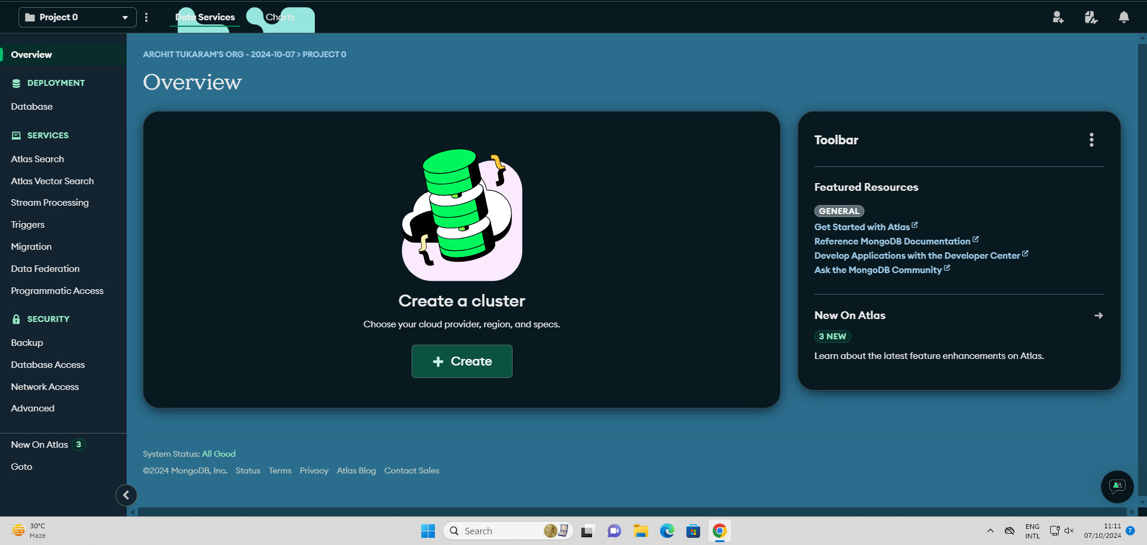

**Create a free cluster**

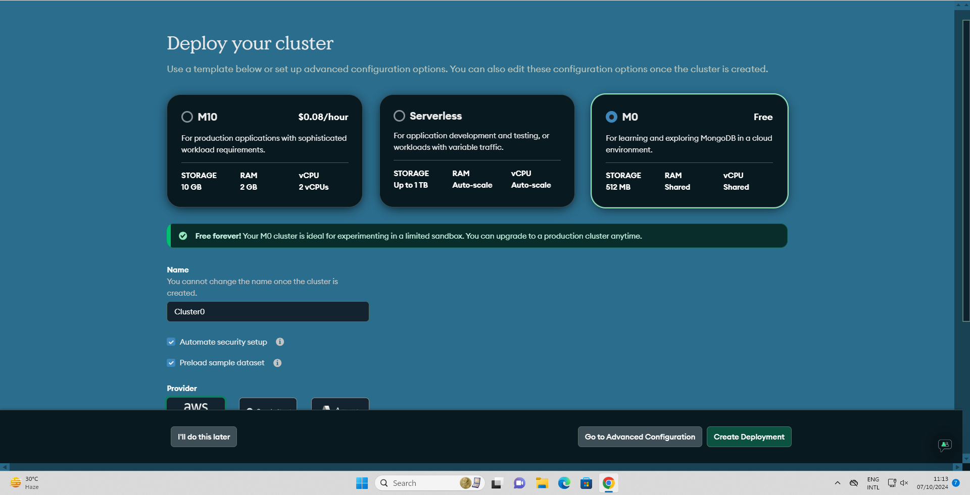

**Set username and password for the cluster and update cluster administrator**

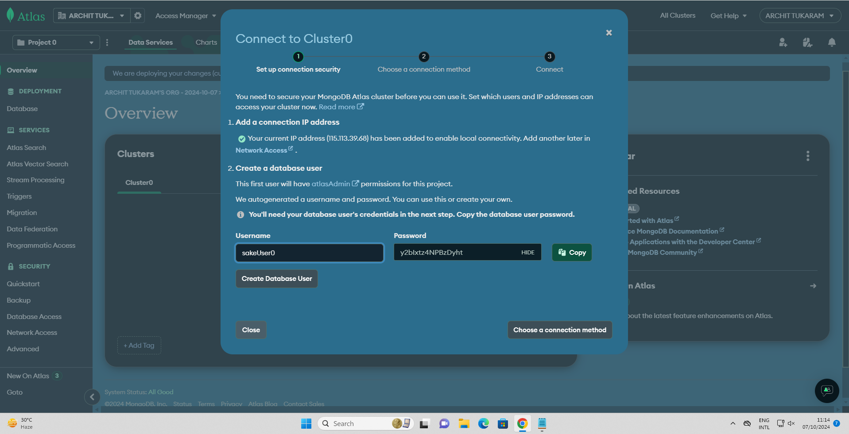

**Choose a connection method (mongoDB compass or mongoDB atlas)**

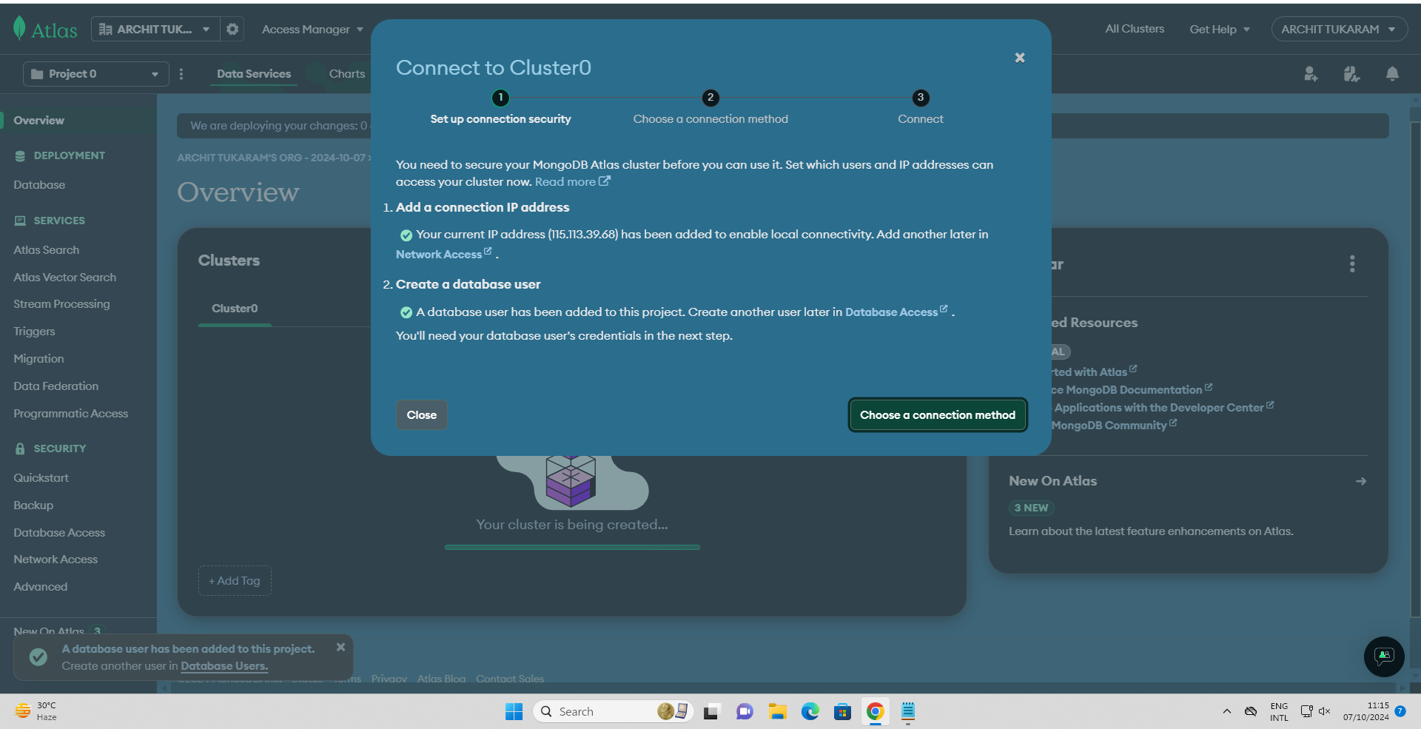

**Selecting mongoDB compass**

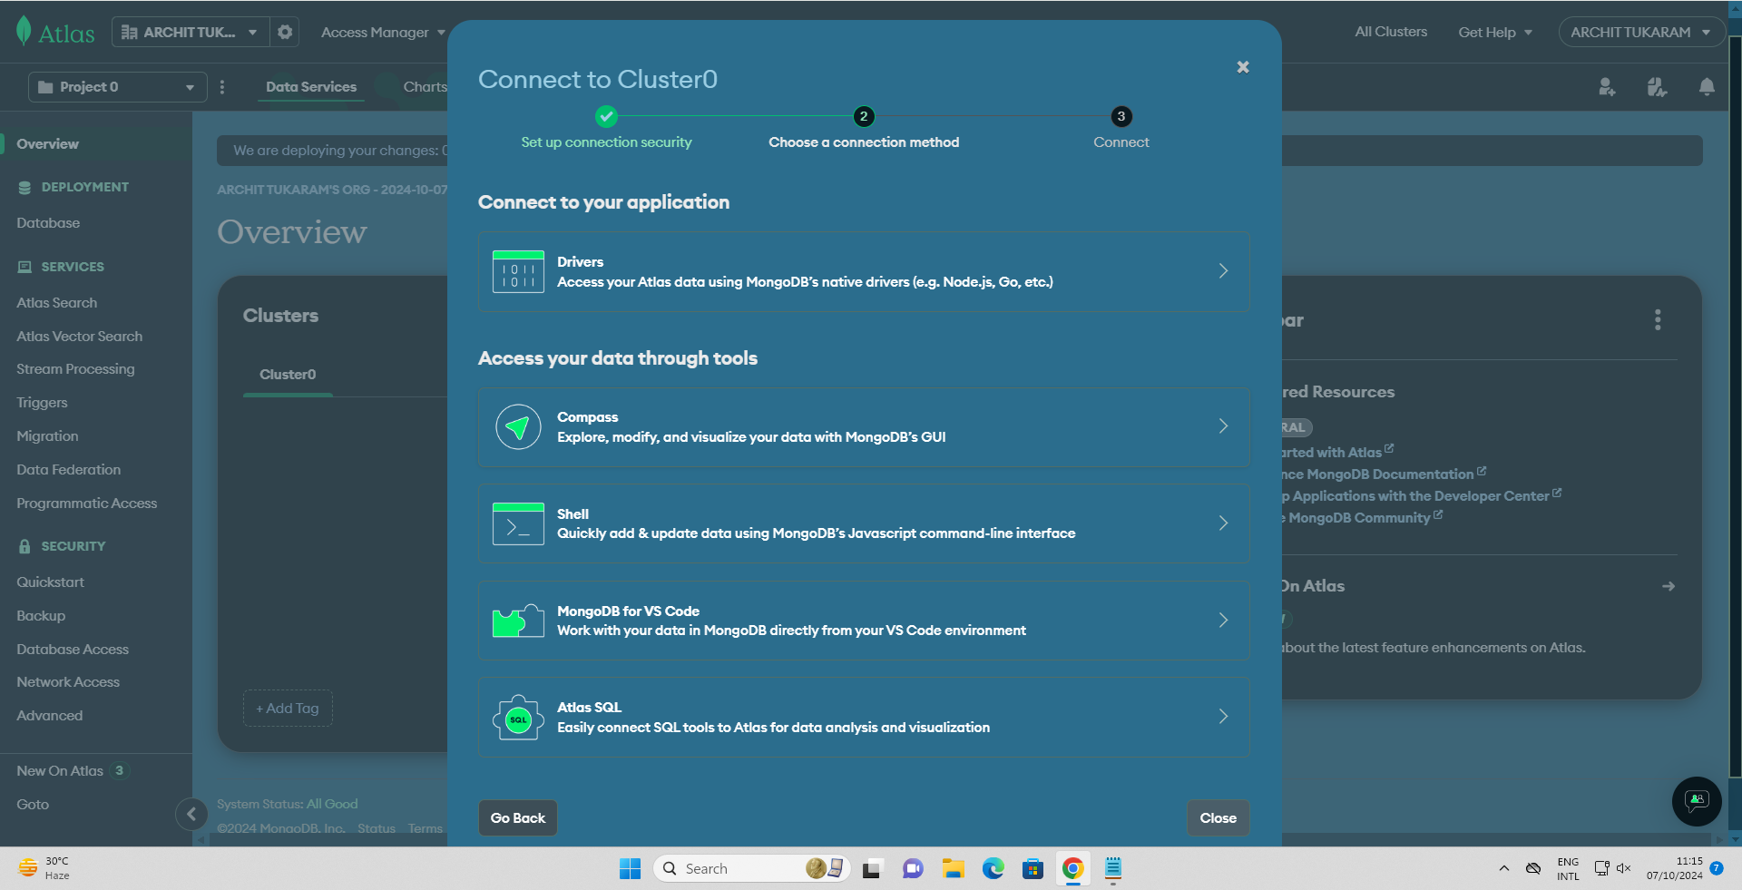

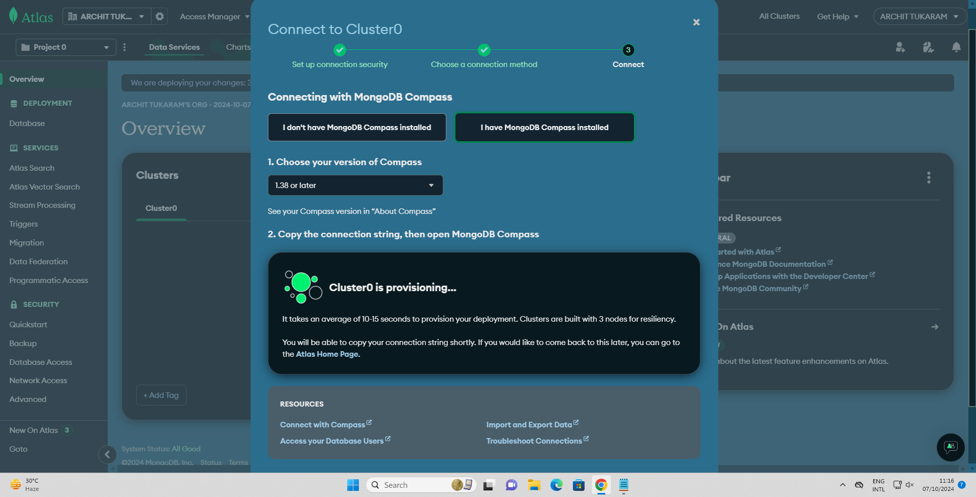

**Update the network access of cluster to anywheree (IP = 0.0.0.0)**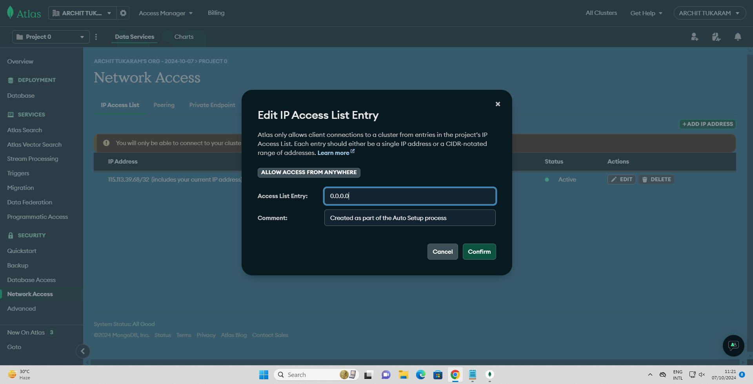

**Open mongoDB compass on local system**

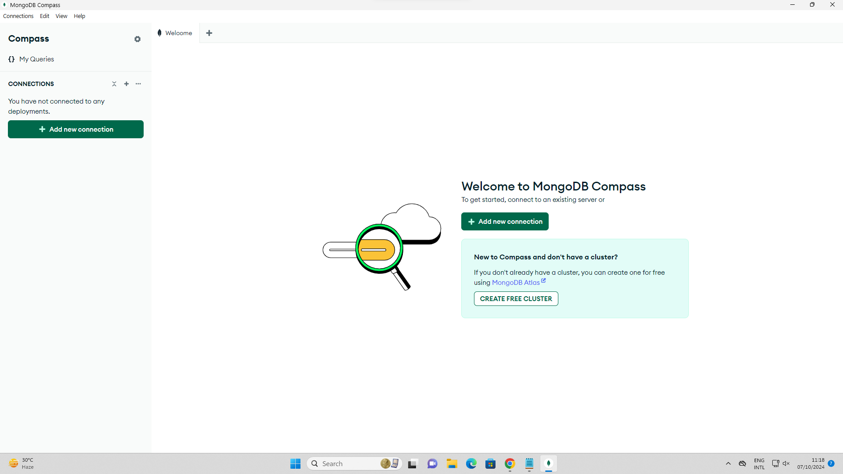

**Connection established**

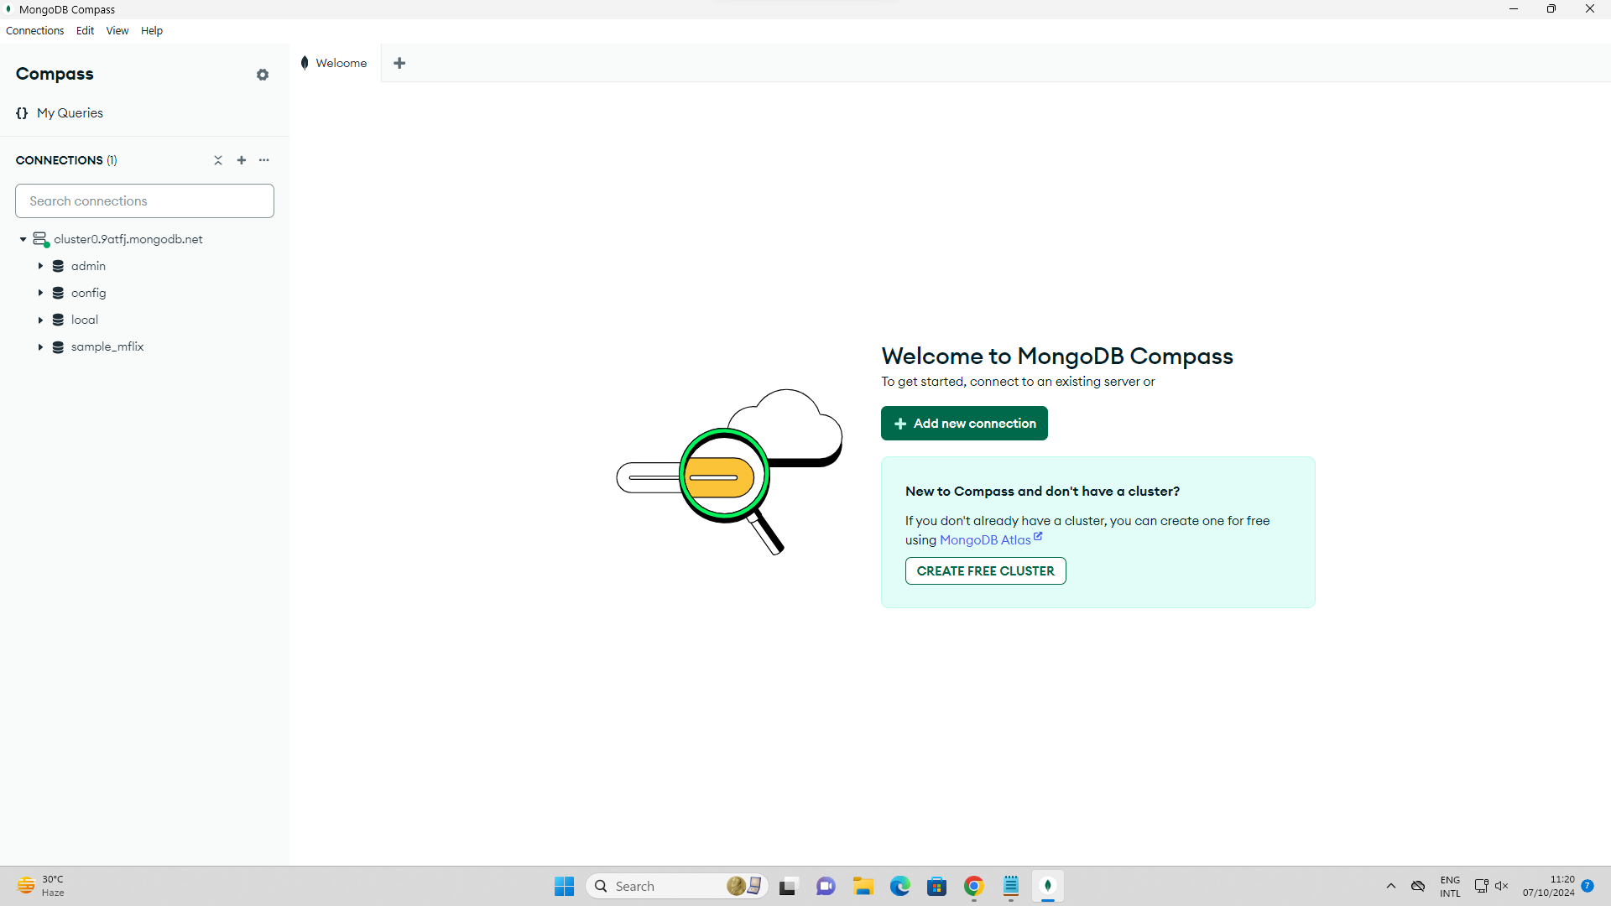

**Cluster is ready of connection**

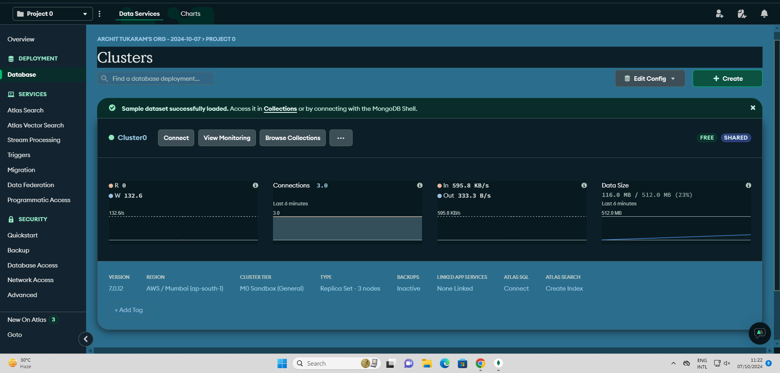

**Run Queries**

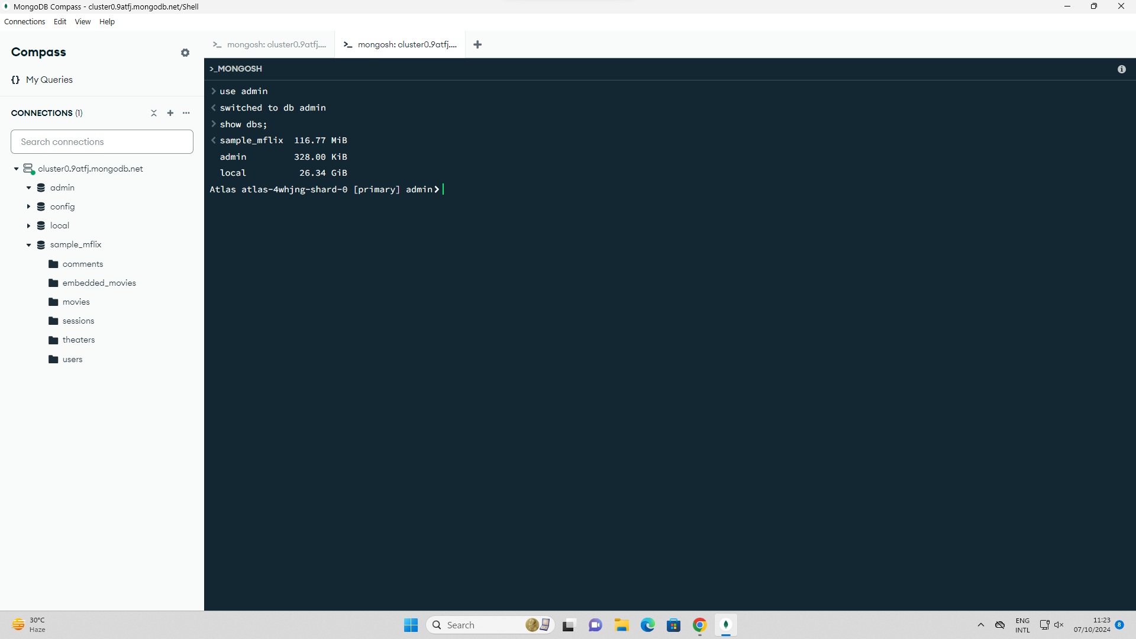

**Show dbs;**

**use movies;**

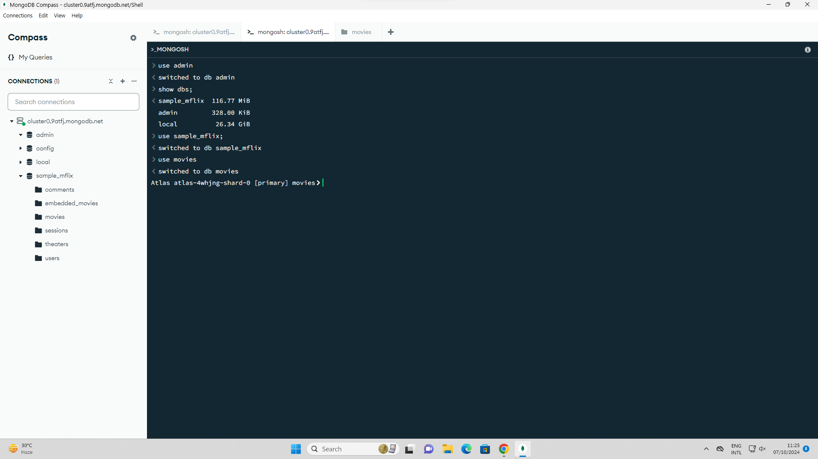

**db.movies.insertOne**

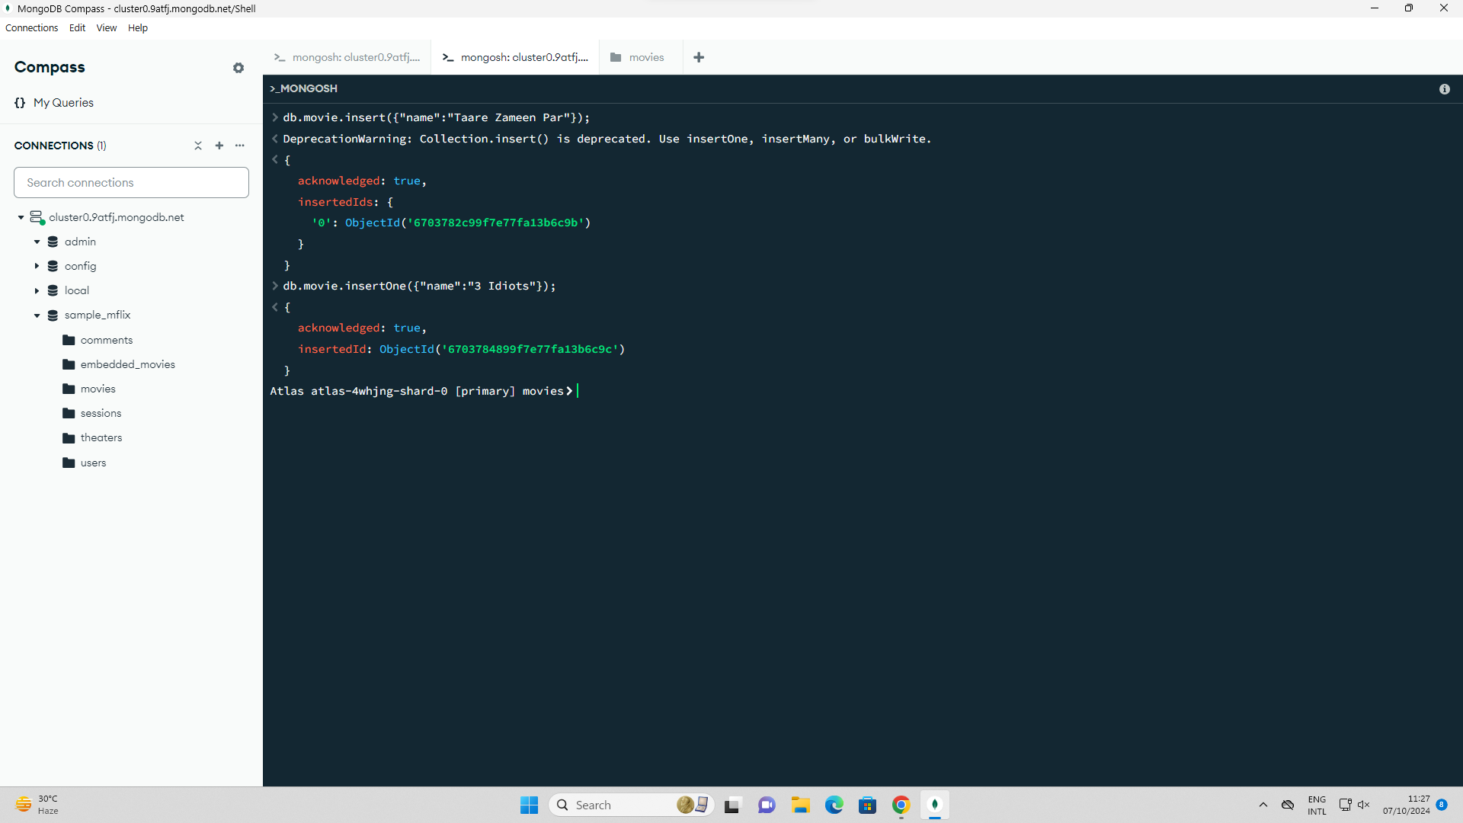

**db.movies.findOne() (OR and AND Method)**

